**Cavway X1 User Manual**

Dec 2024 Rev. A

Siwei Tian & Marco Corvi

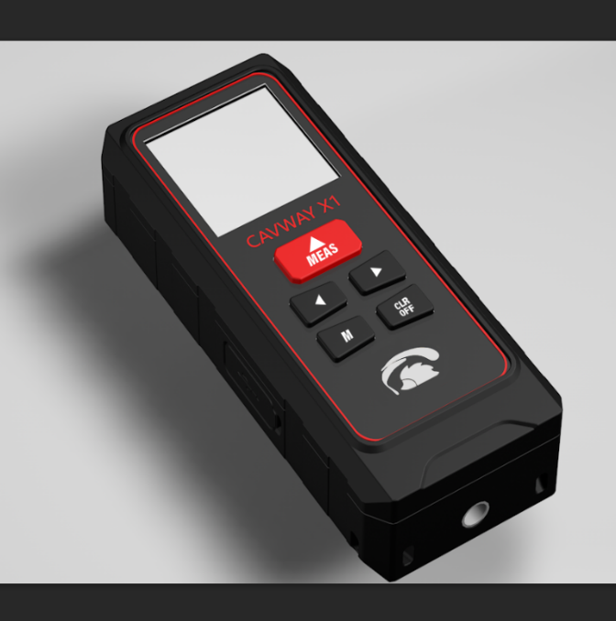The Cavway X1 is an integrated electronic device for cave surveying. It has the following features:

* Good ergonomic:

145g weight and 131*55*33 mm size

* High Accuracy:

Distance < 5mm

Azimuth < 0.4°

Inclination < 0.2°

* IP67 Waterproof
* USB-C port supporting charging and data transfer.
* Two pairs of triaxle G and M sensors. robust anti calibration loss and good performance on magnetic interference detection.

There are five buttons:

* Measure: “DIST”
* Left: “<”
* Right: “>”
* Menu / Enter: “M”
* Clear / Off: “CLR”

**Measure**

A press on the top button, "DIST", turns the device on. The display shows the date and the time. A long press on the CLR button switches the Cavway X1 off.

Pressing the "DIST" button, the laser turned on and the display shows azimuth and inclination. Pressing it another time the distance measurement is taken and the data is stored in memory. The values are shown on the display. There is an error warning on the display if the device detects an error, and the "beep" sound lasts longer. Whenever three or more consecutive close shots are taken the Cavway X1 emits a double beep and flashes the screen. There will be a “LEG” symbol shown on the screen. If there is a “ACC ERR” symbol shown, there might be some magnetic interference around. If “ACC ERR” appears frequently and there is no magnetic interference, check your calibration.

**Hotkey:** Long press “<” shows the accuracy error information details of current shot.

long press “>” enters the confirmation dialog of clearing unsent shots.

**Memory mode**

Pressing the "<" or the ">" button the Cavway X1 enters the memory mode: data in memory are shown on the display. The most recent data on the top. It is possible to scroll up ("<" button - more recent data) and down (">" button - older data) in the list.

The character 'E' on the left indicates a data error. The character 'C' denotes a calibration data. The numbers in bold indicate a leg. The data that have not been transferred have a '*' on the right. Pressing “M” button enters the shot detail page.

On the shot detail page, the "M" button cycles through the info of the highlighted data: readings, errors, and G/M/dip values. The "<" and ">" buttons move to the previous and next shot in memory, respectively, without changing info-page.

**Hotkey**: long press “>” enters the confirmation dialog of clearing unsent shots.

  

**Menu mode**

Pressing the "M" button opens the configuration menu of the Cavway X1:

* Calibration
* Clr. Unsent
* Options
* Information
* Advan. Menu

The "<" and ">" buttons move through the choices. You select a choice with the "M" button. A press of the "CLR" button returns to normal mode.

**Calibration**

With this menu the device enters the calibration mode, which is used to calibrate the Cavway X1.

**Clr. Unsent**

This menu clears the flag of the data that have not been transmitted yet. There is a confirmation dialog.

**Options**

The options are (bold values are the default)

* Reference (**rear**, tail, tripod, front, custom)
* Shot Delay (from 0 to **9** second)
* Backlight (0 to **10**; 0 no backlight, 10 max brightness)
* Volume
* Idle time-off (**60**, 120, 180, 240, 300 seconds)

The "<" and ">" buttons move through the options. The value of each setting is adjusted with the "M" button, cycling through the available values. The "CLR" button goes back to the main menu.

The possible values for the reference are

* Rear: the distance is measured from the rear end of the instrument
* Tail: the distance is measured from the tail on the rear of the instrument.
* Front: the distance is measured from the front end of the instrument
* Tripod: the distance is measured from the point of attach of a tripod
* Custom: this choice is for a custom tail. The laser reading is taken from the rear end of the instrument, but the distance has an additional value specified (in mm). For instance, is the custom value is 20 mm and the reading is 1 m the distance is 1.02 m.

The backlight of the display changes accordingly to the setting while it is adjusted. The value '0' is a dark screen.

**Information**

The information menu displays the hardware version, the firmware version, the serial number, and the battery charge. Cavway X1 adopt a 1800mAh non-magnetic battery, which is three times that of the DistoX2.

**Advanced Menu**

The advanced menu has

* Shot options
* Calibration options
* Time
* Units
* Factory reset

**Shot options**

* The shot accuracy options are (bold values are the default) Error detection (**ON** or OFF)
* Angle difference (0.2, 0.3, **0.4**, 0.5, 0.6, 1.0 degrees)
* ABS error limit (0.5, 0.8, **1.0**, 1.5, 2.0, 3.0 percent)
* Dip error limit (0.5, 0.8, **1.0**, 1.5, 2.0, 3.0 degrees)
* Reset to default values
* Reset the statistics

The angle difference is the difference between the device directions measured by the two pairs of G-M sensors. The absolute limit is the percent difference between the values of the magnetic fields measured by the two M sensors. The dip limit is the difference between the G-M angles measured by the two pairs of GM sensors.

**Calibration options**

The calibration options are (bold values are the default)

* Error detection (**ON** or OFF)
* Group limit angle (1, **3**, 4, 5, 6, 8, 10 percent)

The group limit angle is the threshold for the automatic detection of the shots of a group. The Cavway X1 automatically detects when the user starts a new group after completing one. To complete a group the user must take four or more shots in the same direction, rotating the device by 90 degrees each time. If more than four shots are taken only the last four are considered for the group. When a group is completed the Cavway X1 emits a double beep.

**Time**

With the time menu the user can set year, month, day, hour, minute, and seconds. The values are adjusted with the "<" and ">" buttons. The "M" button moves to the next value: from "year" to "month", from "month" to "day" and so on. After "seconds" it goes back to "year". The "Back" (CLR) button saves the time.



**Units**

The only units choice is for the distance: m (meter) or ft (feet). The angles are always in decimal degrees.

**Calibration**

The Cavway X1 utilizes the same calibration method as the Disto X2/XBLE, with additional features for calibration assistance and error detection. Notably, the Cavway X1 can be calibrated independently without the need for an app on smartphones or tablets. To initiate calibration mode, navigate to the menu and select "Calibration".

**Calibration process**

Calibration involves taking groups of four shots. During each group:

1. Fix the rear of the instrument at point A and the laser beam at point B.
2. Take the first calibration shot, then rotate the device by 90 degrees and take the next shot.
3. Repeat until four shots are taken.

While the distance between points A and B is not recorded, it is recommended that the distance exceeds 5 meters for optimal accuracy. After completing one group of shots, change to a new direction and begin a new group.

**Display features**

The display provides a visual map of the angular directions covered by the calibration groups. Two circles represent the upward and downward hemispheres. The directions that are "covered" by the calibration shots are dark. The directions of the groups already taken are shown with a 'x' and that of the group that is being taken with a '+'. A good calibration should darken both circles entirely, requiring at least 14 groups of shots.

 

**Group Management**

The display also shows:

* The total number of groups completed.
* The number of shots in the current group.

When a group contains four valid shots, it can be accepted and stored. If more than four shots are taken, only the last four will be considered. If an error occurs during a shot, the group can be reset (i.e., all shots cleared). If a shot deviates significantly from the previous shots, it will start a new group. Only groups with four valid shots are saved; otherwise, they are discarded. The group data can be manually reset at any time using the “>” button.

**Calibration Coefficients Computation and Reporting**

Once more than eight complete groups have been captured, the calibration process can be computed by pressing the "M" button. This action generates a detailed calibration report for each sensor pair, which includes:

* Average Error: The mean angular error across the shots in the group.
* Standard Deviation: A measure of the variability in the angular errors.
* Maximum Error: The largest observed angular error.

The error of a shot is defined as the angular difference between the recorded data and the average direction of the shot group after the calibration is applied.

The report also provides:

* The number of iterations performed during the computation.
* The angle between the gravitational direction (G) and the magnetic direction (M), also known as the "magnetic dip."

The raw data from calibration shots can be viewed in the memory dialog for further analysis or review.

After the calibration coefficients are computed, the user has the option to:

1. Apply the Coefficients: Press the "M" button to put the computed calibration into use.
2. Discard the Coefficients: Press the "CLR" button to discard the calibration and return to the main calibration interface.

After discarding or applying the calibration, users can choose to continue capturing additional groups of shots to further refine the process.

 

**Firmware upgrade**

The upload of a new firmware can be done with the Windows program Cavway Assistant.

* Open the Cavway Assistant on the PC
* Connect the Cavway X1 to the PC with a USB cable, and keep the Cavway X1 off
* Turn on the Cavway X1 in boot mode: press the '<' and '>' buttons simultaneously, hold them and press the 'DIST' button.
* Click the 'Connect' button on the Cavway Assistant. You might have to click it a few times before the program is connected to the Cavway, and the button displays "Disconnect".
* When the program shows that it is connected to the Cavway X1, click the 'Firmware' button. In the coming dialog you can open a firmware file from the PC or use the file bundled in the program.
* Press the 'Upgrade' button and wait for the upload to finish. The firmware upload process is shown also on the Cavway X1 display.
* When finished the Cavway Assistant reports whether the upload was complete ("Success") or not. A successful message also shown on the Cavway X1 display.
* After the program shows "Success" shutdown the Cavway X1 pressing and holding the 'CLR' button.
* Turn it on in normal mode by pressing the 'DIST' button.

WARNING: All data stored will be erased during firmware upgrades including the calibration and history data.

  

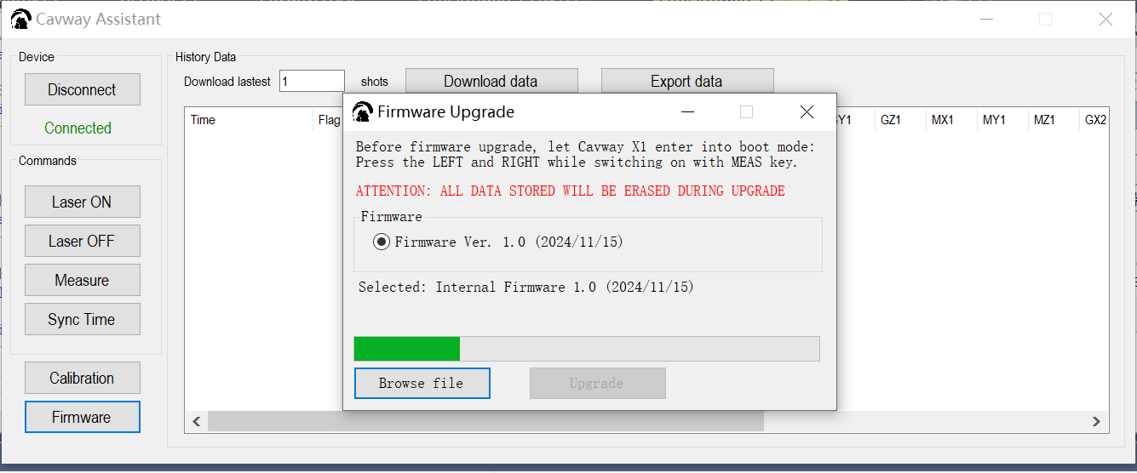

**Cavway Assistant**

All history data stored can be downloaded by Cavway Assistant. Data downloaded is shown in a form including the Distance, Azimuth, Inclinations, absG, absM, dip and the RAW data of 2 sets of sensors. By “Export data” button, the data can be export to csv format.

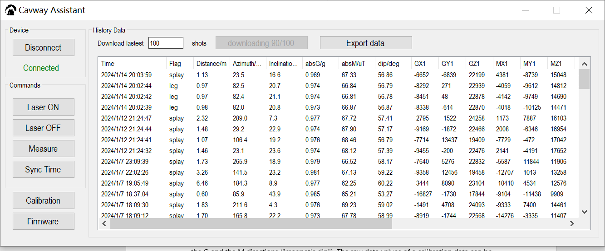

Calibration data can be downloaded and stored locally.

The “Download Coeffs” button downloads and displays the calibration [coefficients](https://www.google.com/search?sca_esv=963e6bd44828a6b7&sxsrf=ADLYWIIteROwLb4N3uSO_b9ud6EQ4C7pyw:1734533237611&q=coefficients&spell=1&sa=X&ved=2ahUKEwijkOrrx7GKAxU9IjQIHbC6OqwQkeECKAB6BAgcEAE) parameters of the 2 sets of sensors. “Save Coeffs” button stores them in local disk (.coe format). Calibration [coefficients](https://www.google.com/search?sca_esv=963e6bd44828a6b7&sxsrf=ADLYWIIteROwLb4N3uSO_b9ud6EQ4C7pyw:1734533237611&q=coefficients&spell=1&sa=X&ved=2ahUKEwijkOrrx7GKAxU9IjQIHbC6OqwQkeECKAB6BAgcEAE) parameters can be loaded from local disk and uploaded to device.

